LM317 quiz

Instructions
Answer the following questions based on the LM317 circuit below, the LM317 data sheet, and the following assumptions:
a) For the NPN transistors, assume V_{be} saturation = 0.6V, V_{ce} saturation = 0.1V, and β = 200
b) AREF = 4.6V
c) Resistors may have different values than in your physical circuit. Use the values in the enclosed diagram.
I strongly encourage you NOT to guess ... intuition is a terrible guide in this jungle, and you'll have much better success following the paths of Masters Ohm, Kirchhoff, Voltage Divider Equation, characteristics of the devices, etc.

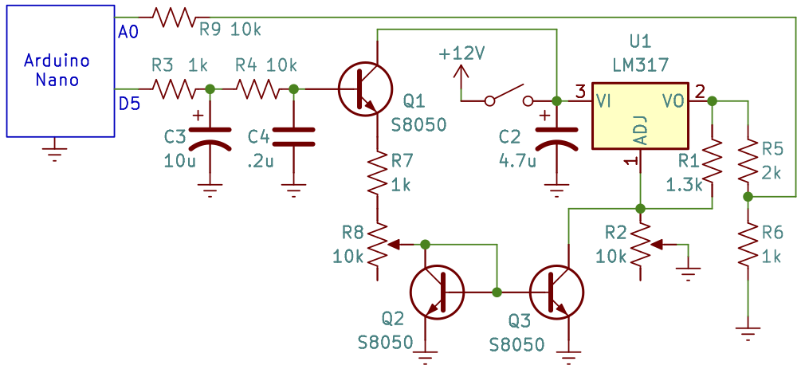

Unit conversion
- What value will analogRead(A0) return when DC Vout = 9V?

- 142
- 667
- 840
- 1000
- 1840

- What will be the voltages on pin D5 following analogWrite(5, 180);?

- 0.81VDC and 0VAC
- 0.81VDC and 2.3VAC
- 0.81VDC and 2.5VAC
- 3.25VDC and 0VAC
- 3.25VDC and 2.3VAC

LM317
- The LM317 datasheet says the voltage between the OUT and ADJ pin is 1.25V. How much current flows through R1?

- 100uA
- 470uA
- 1mA
- 2.7mA
- 4.7mA

- When the LM317 is outputting its maximum voltage, R2 is at its minimum value.

- True
- False

- How much current flows through R2 when it's in the middle of its range (5K)?

- 100uA
- 470uA
- 1mA
- 2.7mA
- 4.7mA

- What's the voltage across R2 when it is in the middle of its range, assuming Q3 is off (Ic~10uA leakage)?

- 4.4V
- 6.6V
- 8.8V
- 11V
- Assuming Q3 is off (Ic~10uA leakage), what is DC Vout when R2 is in the middle of its range?

- 4V
- 6V
- 8V
- 10V

PWM filter
- The corner frequency of the first stage of the PWM filter is

- 7Hz
- 80Hz
- 980Hz
- 10kHz

- The corner frequency of the 2nd stage of the PWM filter is

- 7Hz
- 80Hz
- 980Hz
- 10kHz

- If analogWrite set the voltage on pin D5 to 3.0VDC, then the steady-state voltage on the base of Q1 will be

- 0.14VDC and 0VAC
- .14VDC and 2.5VAC
- 2.4VDC and 0VAC
- 3.0VDC and 0VAC
- 3VDC and 2.5VAC

Emitter follower
- If the base of Q1 is 3.0VDC, then the emitter of Q1 will be at

- 0VDC
- 0.6VDC
- 2.4VDC
- 3.0VDC
- 3.6VDC

Putting it all together
- Extra credit: If R2 = 5kohm and Q3's collector current is 0.95mA, what is DC Vout?

- 4V
- 6V
- 8V
- 10V

- Extra credit: What do you predict DC Vout would be for PWM = 192?

- 4
- 6
- 8
- 1

